Pedro Schmidt

Csci 465

Infix = 8-1+2

(8-(1+2))

(-8(1+2)

(-8+(1)(2))

Prefix = -8+12

Q2. 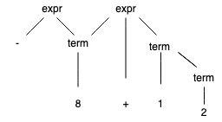

Prefix = -8+12

(-8(+1)(2))

(-8)(1)(2)+)

(8(1)(2)+-)

Postfix = 812+-

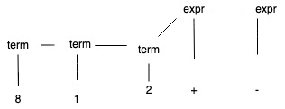

Infix = 8-1+2

(8-1+2)

((-8)1+2)

Prefix= (((-8)+1)2)

